

SCHOOL OF MEDICAL SCIENCES

ANAT2341

Embryology: Early and Systematic Development
2010



Dr Mark Hill
(Course coordinator)

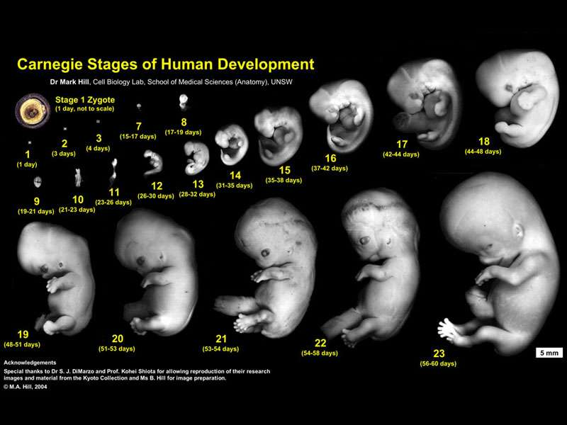

Figure showing the first 8 weeks of human embryological development.
UNSW Course Outline

- Location of the course
School of Medical Sciences, Embryology: Early and Systematic, ANAT2341, S2, 2010

- Table of Contents
Page 2 - course location, table of contents, staff contact details, course details
Page 3 - Rationale for the inclusion of content and teaching approach, teaching strategies, assessment
Page 4 - Academic honesty and plagiarism, course schedule
Page 5 - Expected Resources for students, course evaluation and development, Occupational Health and Safety, Student equity and diversity

- Staff Contact Details
Position | Name | Email | Availability; times and location | Phone
Course Convener | Dr Mark Hill | m.hill@unsw.edu.au | Mon 11-1, Wed 11-1; WW room G20 | 93852477
Lecturer/tutor | Dr Nalini Pather | n.pather@unsw.edu.au | By appointment | 93858025
Lecturer/tutor | Dr Steve Palmer | s.palmer@unsw.edu.au | By appointment
Lecturer/tutor | Dr Antonio Lee | a.lee@unsw.edu.au | By appointment

- Course details

Credit Points:
6

Summary of the Course
This course will introduce embryological development as a major topic within medical sciences. Students completing this course will have a broad understanding of: human development, some animal models of development and current related research topics. Experts and researchers from within the field contribute to the current course.

Aims of the Course
- This course will enable students to explore and gain further understanding of embryology through the investigation of development in both humans and animal models with a direct emphasis of their application to emerging research and reproductive technologies.
- This course will enable students to broadly understand abnormalities in development and current applications to medical research.

Student learning outcomes
At the conclusion of this course the student will be able to:
- Describe the key events in early and systematic embryological development.
- Apply developmental theory to abnormalities of development and current medical research techniques.
- Complete tasks in scientific communication either online, written and by oral presentation.
- Work in small research groups and carry out peer assessment by completing an online group project.

Graduate Attributes
The students will be encouraged to develop the following Graduate Attributes by undertaking the selected activities and knowledge content. These attributes will be assessed within the prescribed assessment tasks.

At the conclusion of this course the student will be able to:

- Investigate embryological development by scholarly enquiry of research literature.
- Apply developmental theory to anatomical development.
- Undertake basic research by applying analytical and critical thinking.
- Create online individual and group projects that demonstrate initiative and collaborative work.

- Rationale for the inclusion of content and teaching approach
This course includes content to enable students to develop communications skills and practices that will enhance their development as a medical researcher. It reflects my position that students should be able to use the latest tools in information technology and online practices.

- Teaching strategies
Each week 2 lectures will introduce topics of early embryological development and later focus upon systematic development. Laboratories are designed to complement the course lecture material, allow individual and small group work and also include topics related to specific researchers within the school. Laboratories also include time for tutorials in online group project work and for to discuss and co-ordinate the group project.

- Assessment
There are three main forms of assessment tasks shown below.

Assessment task | Length | Weight | Learning outcomes assessed | Graduate attributes assessed | Due date
Individual Tasks | Throughout the semester | 20 % | Critical thinking and initiative, information literacy | Scholarly enquiry of research literature | Throughout the semester
Group Project | One online project page | 20 % | Information literacy and effective communication | Initiative and collaborative work | Week 8 peer assessment, Week 10 final assessment
Theory Examination | 2 hours | 60 % | Engagement with the relevant disciplinary knowledge in its interdisciplinary context | Apply developmental theory to anatomical development | Within the S2 exam period 29 Oct to 16 Nov

More detailed assessment information can be found online:

http://php.med.unsw.edu.au/embryology/index.php?title=ANAT2341 Embryology 2010

Submission of Assessment Tasks
All student individual and group assessment tasks will be submitted online, except for some specialized tasks submitted by guest lecturers. Submission dates will be given when the task is initially set and late submissions penalized by 5% / day late.

- Academic honesty and plagiarism
Plagiarism is using the words or ideas of others and presenting them as your own. Plagiarism is a type of intellectual theft. It can take many forms, from deliberate cheating to accidentally copying from a source without acknowledgement. The University has adopted an educative approach to plagiarism and has developed a range of resources to support students.

For more information see: http://www.lc.unsw.edu.au/plagiarism

- Course schedule
The provisional 2010 timetable is shown below and is subject to change without notice, some content may also be replaced by specialist invited guest lecturers.

Week | Monday Date | Lecture 1  Mon 10:00 - 11:00am Wallace Wurth LG03 | Lecture 2  Tue 10:00 - 11:00am Biomedical Theatre E | Laboratory  Thu 9:00 - 11:00am Wallace Wurth 110 Hybrid Lab
2 | 26 Jul | Embryology Introduction | Cell Division/Fertilization | Lab 1
3 | 2 Aug | Week 1&2 Development | Week 3 Development | Lab 2
4 | 9 Aug | Mesoderm Development | Ectoderm, Early Neural, Neural Crest | Lab 3
5 | 16 Aug | Early Vascular Development | Placenta | Lab 4
6 | 23 Aug | Endoderm, Early Gastrointestinal | Respiratory Development | Lab 5
7 | 30 Aug | Head Development | Neural Crest Development | Lab 6
 | 4 Sep | Mid-semester | break
 | 13 Sep | Group Project Due Date | Peer Assessment
8 | 13 Sep | Musculoskeletal Development | Limb Development | Lab 7
9 | 20 Sep | Kidney | Genital | Lab 8
10 | 27 Sep | Sensory - Ear | Sensory - Eye | Lab 9
 | 27 Sep | Group Project Due Date | Final Assessment
11 | 4 Oct | Public Holiday | Endocrine Integumentary | Lab 10
12 | 11 Oct | Heart | Fetal | Lab 11
13 | 18 Oct | Birth, Postnatal | Revision | Lab 12
 | 23 Oct | Study Week
 | 29 Oct | to 16 Nov | Examination - TBA

Laboratories above relate to lecture content for each week or specialist researcher presentations and topics. Time is made available in some labs for project group work.
See also online: http://php.med.unsw.edu.au/embryology/index.php?title=ANAT2341_Course_Timetable_2010

- Expected Resources for students

Textbooks - Either of the textbooks listed below are recommended for this course and page references to both are given in each lecture. There are additional embryology textbooks that can also be used, consult course organizer.

- The Developing Human: Clinically Oriented Embryology (8th Edition) by Keith L. Moore and T.V.N Persaud http://www.us.elsevierhealth.com/isbn/9781416037064
- Larsen’s Human Embryology (4th Edition) by GC. Schoenwolf, SB. Bleyl, PR. Brauer and PH. Francis-West http://www.elsevier.com/wps/find/bookdescription.cws_home/713963

Online materials - The course is supported by a new online education site UNSW Embryology http://php.med.unsw.edu.au/embryology. Each student will be provided access to an online page for their individual assessments and the group project. Blackboard is not currently used for this course.

Additional online resources –

- School of Medical Sciences (SOMS) http://medicalsciences.med.unsw.edu.au/medsciences.nsf
- SOMS Occupational Health and Safety (OHS) http://medicalsciences.med.unsw.edu.au/somsweb.nsf/page/OHS
- UNSW Library website http://info.library.unsw.edu.au/web/services/services.html
- Original Embryology website http://embryology.med.unsw.edu.au/
- Cell Biology Laboratory (student projects) http://php.med.unsw.edu.au/cellbiology/index.php?title=Cell_Biology_Projects

- Course evaluation and development
Periodically student evaluative feedback on the course is gathered, using among other means, UNSW's Course and Teaching Evaluation and Improvement (CATEI) Process. Student feedback is taken seriously, and continual course improvements are based in part on such feedback. For example, previous student feedback on lecture slides availability and online materials navigation has led to changes in both lecture presentations and development of a new online resource with better navigation and access.

- Other information to be included

  - Students are expected to attend all lectures and laboratories and absences require prior arrangement with the course coordinator and/or a medical certificate. See also the UNSW Student conduct policy https://my.unsw.edu.au/student/academiclife/assessment/StudentConductPolicy.html
  - Information on relevant Occupational Health and Safety policies and expectations as outlined at: http://www.hr.unsw.edu.au/ohswc/ohs/ohs_policies.html http://medicalsciences.med.unsw.edu.au/somsweb.nsf/page/OHS
  - Theory examination will be a two-hour exam in the semester 2 examination period.
  - Students should refer to the UNSW website for further advice concerning special consideration in the event of illness or misadventure https://my.unsw.edu.au/student/atoz/SpecialConsideration.html
  - Student equity and diversity issues via Student Equity Officers (Disability) in the Student Equity and Diversity Unit (9385 4734). Further information for students with disabilities is available at http://www.studentequity.unsw.edu.au/content/Services/Disabilityservices.cfm

